EXP NO. 9 Develop an Android Calculator Application using
Android Studio
AIM:
To develop a simple Android Calculator application using Button, TextView, and EditText for Addition, Subtraction, Multiplication, and Division.
ALGORITHM:
- Initialize the Android Application:
  - Set up a new Android project in Android Studio.
  - Create a MainActivity Java or Kotlin file for the main screen of the application.
- Design the User Interface (UI):

  - Create the following UI components in the XML layout file: EditText for input fields where the user will enter numbers (two
EditTexts for number1 and number2).

Buttons for each arithmetic operation (Addition, Subtraction, Multiplication, Division).

TextView to display the result of the operation.
- Declare Variables:
  - Create variables for the EditText fields, Buttons, and TextView.
  - Define variables to hold the input numbers and the result (e.g., num1, num2, result).
- Get Input from the User:
  - Get the values entered by the user in EditText fields using getText().toString() and convert them to numerical values (like Integer.parseInt() or Double.parseDouble()).
- Set Event Listeners for Buttons:
  - For each button (Addition, Subtraction, Multiplication, and Division), set an OnClickListener.
  - Inside the onClick() method for each button, perform the respective arithmetic operation:

Addition: result = num1 + num2



Subtraction: result = num1 - num2 Multiplication: result = num1 * num2

Division: result = num1 / num2 (add validation to prevent division by zero).
- Perform Arithmetic Operation:
  - Check which button was clicked (using view.getId()), and based on the button, perform the respective arithmetic operation.
  - Handle Division by Zero: Check if num2 is 0 before performing division and show an appropriate error message if true.
- Display the Result:
  - Use TextView to display the result of the operation.
  - Convert the result to a string and set it using setText() method on the TextView.
- Validate User Inputs:
  - Before performing any operation, validate the input to ensure the user has entered valid numbers (not empty or non-numeric characters).
- Handle Edge Cases:
  - Ensure the app handles cases where users input invalid values or attempt division by zero. Display appropriate messages for errors.
- Finish the Operation:
  - Once the result is displayed, the user can either perform another calculation or exit the app.
CODE:
ACTIVITY.XML
<?xml version="1.0" encoding="utf-8"?>
<LinearLayout xmlns:android="http://schemas.android.com/apk/res/android" android:orientation="vertical"
android:padding="20dp" android:layout_width="match_parent" android:layout_height="match_parent">

<!-- Input 1 -->
<EditText android:id="@+id/num1"
android:hint="Enter first number" android:inputType="numberDecimal" android:layout_width="match_parent" android:layout_height="wrap_content"/>

<!-- Input 2 -->
<EditText android:id="@+id/num2"
android:hint="Enter second number" android:inputType="numberDecimal" android:layout_width="match_parent" android:layout_height="wrap_content"/>

<!-- Buttons -->
<LinearLayout android:orientation="horizontal" android:layout_width="match_parent" android:layout_height="wrap_content">

<Button android:id="@+id/add" android:text="+" android:layout_weight="1" android:layout_width="0dp" android:layout_height="wrap_content"/>
<Button android:id="@+id/sub" android:text="-" android:layout_weight="1" android:layout_width="0dp" android:layout_height="wrap_content"/>
<Button android:id="@+id/mul" android:text="*" android:layout_weight="1" android:layout_width="0dp" android:layout_height="wrap_content"/>
<Button android:id="@+id/div" android:text="/" android:layout_weight="1" android:layout_width="0dp" android:layout_height="wrap_content"/>

</LinearLayout>

<!-- Result -->

<TextView android:id="@+id/result" android:text="Result" android:textSize="24sp"
android:layout_marginTop="20dp" android:layout_width="wrap_content" android:layout_height="wrap_content"/>

</LinearLayout>

MAIN_ACTIVITY.JAVA
package com.example.calculatorapp; import android.os.Bundle;
import android.view.View; import android.widget.*;

import androidx.appcompat.app.AppCompatActivity;

public class MainActivity extends AppCompatActivity {

EditText num1, num2; Button add, sub, mul, div; TextView result;

@Override
protected void onCreate(Bundle savedInstanceState) { super.onCreate(savedInstanceState); setContentView(R.layout.activity_main);

num1 = findViewById(R.id.num1); num2 = findViewById(R.id.num2); add = findViewById(R.id.add);

sub = findViewById(R.id.sub); mul = findViewById(R.id.mul); div = findViewById(R.id.div); result = findViewById(R.id.result);

add.setOnClickListener(v -> calculate('+')); sub.setOnClickListener(v -> calculate('-')); mul.setOnClickListener(v -> calculate('*')); div.setOnClickListener(v -> calculate('/'));
}

private void calculate(char operator) { String s1 = num1.getText().toString(); String s2 = num2.getText().toString();

if (s1.isEmpty() || s2.isEmpty()) { result.setText("Enter both numbers"); return;
}

double n1 = Double.parseDouble(s1); double n2 = Double.parseDouble(s2); double res = 0;

switch (operator) {
case '+': res = n1 + n2; break; case '-': res = n1 - n2; break; case '*': res = n1 * n2; break; case '/':
if (n2 == 0) {
result.setText("Cannot divide by zero"); return;

}
res = n1 / n2; break;
}

result.setText("Result: " + res);
}
}

OUTPUT:
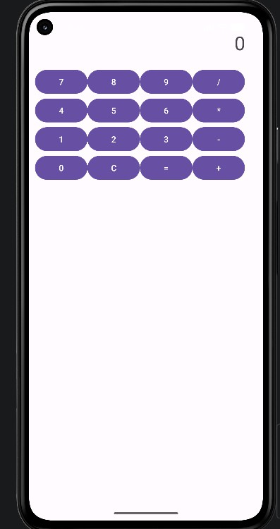
RESULT:
A calculator is designed using Android studio which uses controls like Button, TextView, EditText having basic functionality like Addition, Subtraction, multiplication, and Division.

